**THE MUSMUSCULUS**

**Project Report**

**<Version 1.0>**

Industrial Training Seminar (IDS754)

Degree

**BACHELOR OF TECHNOLOGY (CSE WITH DATA SCIENCE)**

**[I-NURTURE]**

|  |  |
| --- | --- |
| PROJECT GUIDE:  **Vartika Gupta** | SUBMITTED BY:  **Manas Chauhan (TCA2166012)**  **Ali Faiz (TCA2166003)** |

November, 2024



**FACULTY OF ENGINEERING & COMPUTING SCIENCES**

**TEERTHANKER MAHAVEER UNIVERSITY, MORADABAD**

**DECLARATION**

We hereby declare that this Project Report titled **“THE MUSMUSCULUS”** submitted by us and approved by our project guide, Faculty of Engineering & Computing Sciences. Teerthanker Mahaveer University, Moradabad, is a Bonafide work undertaken by us and it is not submitted to any other University or Institution for the award of any degree diploma / certificate or published any time before.

|  |  |  |
| --- | --- | --- |
| **Project ID :** |  | |
| **Student Name:** | Manas Chauhan |  |
| **Student Name:** | Ali Faiz |  |
|  |  |  |
| **Project Guide :** | Vartika Gupta |  |

Table of Contents

1 Project Title 4

2 Problem Statement 5

3 Project Description 5

3.1 Scope of the Work 6

3.2 Project Modules 7

3.3 Context Diagram (High Level) 9

4 Implementation Methodology 9

5 Technologies to be used 12

5.1 Software Platform 13

5.2 Hardware Platform 14

5.3 Tools, if any 14

6 Advantages of this Project 15

7 Assumptions, if any 17

8 Future Scope and further enhancement of the Project 17

9 Project Repository Location 19

10 Definitions, Acronyms, and Abbreviations 20

11 Conclusion 20

12 References 21

**Appendix**

**A: Data Flow Diagram (DFD)**

**B: Entity Relationship Diagram (ERD)**

**C: Use Case Diagram (UCD)**

**D: Data Dictionary (DD)**

**E: Screen Shots**

# Project Title

**"THE MUSMUSCULUS”,** this project aims to investigate protein expression patterns in mice, using data-driven techniques to classify mice into distinct groups based on genotype, behavior, and treatment categories. This project seeks to identify subsets of proteins that are highly discriminative across these categories, potentially unveiling biomarkers that correspond with genetic, behavioral, or treatment variations in mice. By performing a discriminant analysis on the protein dataset, the project contributes to understanding how protein expression profiles can help in categorizing and potentially predicting biological characteristics in different mouse classes. The dataset used in it includes the following details respectively.

Dataset Details:  
The analysis is conducted on a structured dataset titled "dataset Major Project.csv," which encompasses multiple observations of protein expressions across different classes of mice. The key details of the dataset include:

* Genotype: Classification based on the genetic makeup of the mice (e.g., Wild-type, Mutant).
* Behavior: Behavioral traits exhibited by the mice, observed and recorded under controlled conditions.
* Treatment: Indicates the type of treatment administered, if any, distinguishing between control and experimental groups.
* Protein Expression Levels: Quantitative measurements of protein expressions for numerous proteins. These values represent the expression intensities for each protein within individual mice.

**Note:** The dataset consists of multiple rows corresponding to individual mice and columns representing the protein expression levels, as well as categorical information about genotype, behavior, and treatment. The dataset is well-suited for a classification analysis due to its variety in data points and the distinct classes it presents.  
  
**Expected Output:**  
The project will result in a model capable of accurately classifying mice into their respective classes based on protein expression data. Additionally, the output will include a list of key proteins identified as discriminants between classes. These proteins are expected to serve as indicators for variations in genotype, behavior, and treatment, which could contribute to further research in the fields of genetics, behavioral studies, and pharmacology.

**2)Problem Statement: -**

In biomedical research, understanding how genetic, behavioral, and treatment variations affect protein expression is essential for insights into biological mechanisms and potential health implications. Proteins, as fundamental components of cells, play critical roles in virtually all biological processes, and variations in their expression levels can reveal unique biological characteristics associated with specific traits. The _MUSMUSCULUS_ project seeks to address the challenge of identifying key protein biomarkers that can differentiate between groups of mice classified by genotype, behavior, and treatment. This classification is crucial in various research areas, including genetics, pharmacology, and behavioral science, where distinguishing between biological groups based on protein profiles can contribute to targeted treatments and personalized medicine.

Despite the extensive data on protein expression in mice, distinguishing which proteins are significant in separating different classes remains a challenging task due to the high-dimensional nature of proteomics data. This complexity is compounded by the need for accurate and interpretable models that can effectively classify mice into distinct groups and reveal the underlying biological variations. The MUSMUSCULUS project addresses the following core questions:

1. Classification Challenge: How can we accurately classify mice into distinct groups based on their genotype, behavior, and treatment using protein expression data?

2. Discriminant Protein Identification: Which proteins act as primary discriminants for the different classes, and can these proteins be identified as potential biomarkers for genetic or behavioral traits?

3. Predictive Modeling: Can a predictive model be built that not only classifies but also helps interpret the biological relevance of the selected discriminant proteins?

# 3) Project Description: -

In biomedical research, understanding how genetic, behavioral, and treatment variations affect protein expression is essential for insights into biological mechanisms and potential health implications. Proteins, as fundamental components of cells, play critical roles in virtually all biological processes, and variations in their expression levels can reveal unique biological characteristics associated with specific traits. The _MUSMUSCULUS_ project seeks to address the challenge of identifying key protein biomarkers that can differentiate between groups of mice classified by genotype, behavior, and treatment. This classification is crucial in various research areas, including genetics, pharmacology, and behavioral science, where distinguishing between biological groups based on protein profiles can contribute to targeted treatments and personalized medicine.

Despite the extensive data on protein expression in mice, distinguishing which proteins are significant in separating different classes remains a challenging task due to the high-dimensional nature of proteomics data. This complexity is compounded by the need for accurate and interpretable models that can effectively classify mice into distinct groups and reveal the underlying biological variations. The MUSMUSCULUS project addresses the following core questions:

1. Classification Challenge: How can we accurately classify mice into distinct groups based on their genotype, behavior, and treatment using protein expression data?

2. Discriminant Protein Identification: Which proteins act as primary discriminants for the different classes, and can these proteins be identified as potential biomarkers for genetic or behavioral traits?

3. Predictive Modeling: Can a predictive model be built that not only classifies but also helps interpret the biological relevance of the selected discriminant proteins?

## 3.1)Scope of the Work

The "MUSMUSCULUS" project delves into bioinformatics and proteomics, focusing on the classification of mice based on protein expression profiles linked to genotype, behavior, and treatment. This project seeks to identify and analyze discriminant proteins that serve as biomarkers, providing a foundational understanding of how genetic and physiological factors influence protein expression in mammals. The scope of this work spans multiple domains, including data analysis, biomarker discovery, and classification modelling, with several key objectives and potential applications:

1. Data-Driven Classification of Biological Groups: This project aims to leverage protein expression data to classify mice into eight distinct classes. By examining the patterns and trends in high-dimensional proteomics data, the project offers insights into the biological relevance of genotype, behavior, and treatment-based distinctions, enhancing understanding of these factors in biomedical research.

2. Identification of Biomarkers: One of the core objectives is to identify specific proteins that can serve as discriminative markers for different classes. These biomarkers could have applications in genetic research, drug development, and personalized medicine, where understanding protein-based indicators is crucial for disease diagnosis and treatment.

3. Model Development for Predictive Analysis: The scope includes building and refining classification models capable of distinguishing between the eight classes of mice based on proteomic data. These models not only classify but also provide interpretable outputs, which can be applied in bioinformatics and experimental studies that seek to link genotype and phenotype through protein expressions.

4. Exploratory Insights into Proteomic Data: By applying statistical and visual analysis methods to the dataset, the project aims to reveal hidden patterns and relationships within the data, contributing to a more comprehensive understanding of the proteomic landscape in response to genetic, behavioral, and treatment variables.

5. Contribution to Biomedical and Pharmaceutical Fields: The findings from this project could be extended to support advanced research in pharmaceuticals and genetics. For instance, discriminant proteins identified as biomarkers may be used in preclinical studies to evaluate treatment responses, explore gene-protein interactions, and develop diagnostic or therapeutic solutions for diseases linked to specific genetic or behavioral profiles.

6. Establishing a Framework for Future Research: The methodologies and insights generated in the MUSMUSCULUS project could serve as a framework for similar studies in other organisms or in expanded areas of research, such as human disease studies, where protein expression plays a role in disease progression and treatment.

## 3.2) Project Modules

The "MUSMUSCULUS" project is organized into a series of distinct yet interconnected modules, each responsible for specific functions within the data processing, analysis, and classification pipeline. These modules enable a structured approach to achieve the project objectives and facilitate efficient handling of high-dimensional protein expression data for the classification and identification of discriminant proteins.

1. Data Collection and Preprocessing Module

- Objective: Gather and prepare the dataset for analysis.

- Functionality: This module loads the "dataset Major Project.csv" file and performs essential data cleaning and preprocessing tasks. Missing values are handled, outliers are identified, and the data is standardized for consistency across protein expression measurements.

- Outputs: A cleaned and structured dataset ready for exploratory data analysis and modeling.

2. Exploratory Data Analysis (EDA) Module

- Objective: Gain insights into the dataset and understand basic patterns.

- Functionality: In this module, statistical and visual techniques are used to examine the distribution, correlation, and overall structure of protein expression data. Key EDA techniques include generating descriptive statistics, creating visualizations (e.g., heatmaps, box plots), and identifying initial trends that could guide further analysis.

- Outputs: Visualizations and summary statistics that highlight initial findings and potential areas of interest in the data.

3. Dimensionality Reduction Module

- Objective: Reduce the complexity of high-dimensional data while retaining significant information.

- Functionality: Given the large number of proteins, dimensionality reduction techniques such as Principal Component Analysis (PCA) and Linear Discriminant Analysis (LDA) are applied in this module. These techniques help in narrowing down to the most informative proteins and facilitate model training by reducing computational load.

- Outputs: A reduced dataset with fewer features, focusing on the most critical proteins, allowing efficient model building and interpretation.

4. Classification Model Development Module

- Objective: Develop and optimize classification models for grouping mice into distinct classes.

- Functionality: This module involves selecting and testing different classification algorithms (e.g., Decision Trees, Random Forests, Support Vector Machines). The models are trained on the processed data and evaluated based on performance metrics like accuracy, precision, and recall. This module also includes fine-tuning model parameters for optimal performance.

- Outputs: A well-trained classification model capable of accurately categorizing mice into eight classes based on genotype, behavior, and treatment data.

5. Feature Importance and Discriminant Protein Identification Module

- Objective: Identify the most significant proteins that distinguish between different classes of mice.

- Functionality: This module applies feature importance analysis methods, including model-based feature selection and LDA, to pinpoint proteins with high discriminant power. These proteins are likely candidates for biomarkers and are further validated to confirm their significance.

- Outputs: A subset of proteins identified as discriminant markers, with statistical validation supporting their role as potential biomarkers for classification.

6. Result Interpretation and Visualization Module

- Objective: Present the findings in an interpretable and visual format.

- Functionality: This module compiles and visualizes the results from classification and feature importance analysis. Visuals like bar charts, heatmaps, and scatter plots are created to represent the performance of the model, distribution of discriminant proteins, and their contribution to class differentiation.

- Outputs: Graphical and tabular representations of the results, allowing for easy interpretation of model accuracy and the significance of identified proteins.

7. Documentation and Reporting Module

- Objective: Document the workflow, methodologies, and results comprehensively.

- Functionality: This final module compiles all findings, code, and insights into a coherent report. The documentation provides a clear description of each module’s functionality, methodological approaches, and interpretations of the results.

- Outputs: A complete report detailing the entire project, including methodologies, visualizations, insights, and future recommendation

## 3.3) Context Diagram (High Level)



# 4)Implementation Methodology: -

The "MUSMUSCULUS" project follows a structured methodology to analyze protein expression data in mice and classify them into distinct groups based on genotype, behavior, and treatment. This methodology involves systematic steps in data preparation, analysis, model building, and interpretation, ensuring a robust and accurate approach to identifying discriminant proteins. The implementation methodology can be broken down into the following key stages:

1. Data Preprocessing and Cleaning

- Overview: The implementation begins with preparing the raw data from the "dataset Major Project.csv" file, ensuring it is clean, consistent, and ready for analysis.

- Steps:

Handling Missing Values: Missing or null values are managed by either filling them with appropriate statistical measures (e.g., mean or median) or by excluding them based on relevance.

- Standardization: Protein expression values are standardized to ensure uniformity across the dataset, making it suitable for comparison and modeling.

- Outlier Detection: Outliers in protein expressions are identified and handled to avoid skewing analysis results.

2. Exploratory Data Analysis (EDA)

- Overview: This stage provides initial insights into the data, identifying patterns, trends, and any preliminary relationships between protein expressions and the mouse classification attributes (genotype, behavior, treatment).

- Steps:

- Descriptive Statistics: Calculations for means, variances, and distributions give a basic understanding of the dataset.

- Visualization: Heatmaps, box plots, and scatter plots are generated to visually inspect the relationships between variables and identify any initial clusters or correlations.

- Correlation Analysis: Statistical correlation analysis is performed to highlight the relationships between proteins and class-defining attributes, setting the groundwork for feature selection.

3. Dimensionality Reduction

- Overview: To manage the high-dimensional nature of proteomic data, dimensionality reduction techniques are employed to retain only the most significant features.

- Techniques:

- Principal Component Analysis (PCA): PCA is used to reduce the dataset dimensions while preserving variance, helping to identify key patterns within the data.

- Linear Discriminant Analysis (LDA): LDA focuses on maximizing the separability among classes, which assists in feature selection by retaining proteins that are most relevant for classification.

4. Model Building and Classification

- Overview: This stage involves constructing machine learning models to classify mice based on their genotype, behavior, and treatment, as indicated by protein expression data.

- Steps

- Model Selection: Several machine learning algorithms, such as Decision Trees, Random Forests, and Support Vector Machines (SVM), are evaluated for suitability in classifying the dataset.

- Training and Testing: The dataset is split into training and testing sets to train the model and assess its performance.

- Hyperparameter Tuning: Techniques such as grid search or cross-validation are used to optimize model parameters for the best accuracy and reliability.

- Evaluation: Metrics such as accuracy, precision, recall, and F1-score are calculated to evaluate model performance and ensure it meets the project’s classification goals.

# 5. Identification of Discriminant Proteins

# - Overview: Once a model is built, feature importance analysis is performed to identify proteins that serve as discriminant markers, essential for distinguishing between the eight mouse classes

# - Techniques:

# - Feature Importance Ranking: Techniques like feature importance scores (from Random Forests) and coefficient analysis (from LDA) help to rank proteins by their relevance.

# - Statistical Validation: Cross-validation is applied to ensure that the discriminant proteins are consistently identified across different samples, adding reliability to the results.

# 6. Result Visualization and Interpretation

# - Overview: To make findings interpretable, results are visualized and documented for easier understanding and communication.

# - Steps:

# - Model Performance Visualization: Confusion matrices, accuracy plots, and feature importance graphs are used to showcase model performance.

# - Discriminant Protein Visualization: Identified key proteins are visualized through bar charts and heatmaps, showing their relative importance across classes.

# -Class Distribution and Protein Expression Analysis: Further visualizations help interpret the distribution of classes and the variation of key protein expressions.

# 7. Documentation and Final Reporting

# - Overview: The final stage involves compiling all methodologies, findings, and insights into a comprehensive report.

# - Steps:

# - Methodology Documentation: Each step, from data cleaning to model building, is documented to ensure transparency and reproducibility.

**5) Technologies to be used: -**  
The "MUSMUSCULUS" project requires a robust set of tools and libraries to handle high-dimensional proteomic data, conduct complex statistical analysis, and develop machine learning models for classification and biomarker identification. The following technologies are chosen for their compatibility, efficiency, and relevance in bioinformatics and data science applications:

1. Programming Languages

- Python: Python serves as the primary programming language for this project due to its extensive libraries and tools for data analysis, visualization, and machine learning. Its versatility and ease of use make it ideal for bioinformatics tasks, allowing for seamless integration of different modules within the project.

2. Data Analysis and Machine Learning Libraries

- NumPy and Pandas: These libraries are essential for data handling and manipulation. NumPy provides efficient numerical operations, while Pandas is used for managing and processing large datasets, making it suitable for handling the complex proteomic data in the project.

- SciPy: SciPy supports statistical operations and advanced mathematical functions, enabling calculations and statistical validations needed for data analysis and feature selection.

- Scikit-Learn: Scikit-Learn is the primary library for implementing machine learning algorithms, including classification, dimensionality reduction (PCA, LDA), and feature selection. Its wide range of tools for model training, evaluation, and parameter tuning is crucial for achieving accurate and reliable classification.

3. Visualization Libraries

- Matplotlib and Seaborn: These libraries are used for creating detailed visualizations, such as scatter plots, heatmaps, and histograms, which aid in exploratory data analysis and result interpretation. Seaborn, built on Matplotlib, is particularly effective for creating visually appealing statistical graphics, which helps in understanding data distributions and correlations.

- Plot ly: Plot ly may be used for interactive visualizations, especially when presenting complex findings like feature importance or protein distribution. Its ability to generate interactive, browser-based plots is valuable for data exploration and reporting.

4. Dimensionality Reduction and Feature Selection Tools

- Principal Component Analysis (PCA): Implemented within Scikit-Learn, PCA is essential for reducing the dataset’s dimensionality, helping in the identification of key proteins and improving model performance by reducing redundancy.

- Feature Importance Analysis: Scikit-Learn’s feature importance functions, particularly those in algorithms like Random Forests, support the identification of discriminant proteins. These techniques help pinpoint the most relevant proteins for classification, serving as potential biomarkers.

5. Statistical Analysis Tools

- StatsModels: StatsModels provides advanced statistical tests and models, which are useful for validating findings, ensuring that the identified discriminant proteins hold statistical significance.

6. Integrated Development Environment (IDE)

- Jupyter Notebook: Jupyter Notebook offers an interactive environment for writing code, running analyses, and visualizing results. It is particularly suitable for data science projects, as it allows for code and output to be displayed together, supporting exploratory work and detailed documentation.

## 5.1) Software Platform

The "MUSMUSCULUS" project leverages a variety of software platforms to support data processing, machine learning, visualization, and documentation needs. These platforms provide a robust environment for executing bioinformatics tasks, ensuring reproducibility, and enhancing efficiency. Below is an outline of the key software platforms utilized:

1. Jupyter Notebook

Jupyter Notebook is an open-source, web-based interactive development environment widely used in data science and bioinformatics. It allows code, visualizations, and markdown text to be organized in a single document, making it ideal for exploratory data analysis and iterative workflows.

2. Python Development Environment (Anaconda)

Anaconda is a popular distribution of Python that comes pre-installed with numerous data science packages and provides a streamlined environment for scientific computing. It includes a package manager (conda) that simplifies the installation and management of dependencies.

3. Data Visualization Tools (Matplotlib, Seaborn, Plotly)

These are Python-based libraries designed to create static, animated, and interactive visualizations. Matplotlib and Seaborn are widely used for statistical plotting, while Plotly allows for interactive, web-based visualizations.

## 5.2) Hardware Platform

The "MUSMUSCULUS" project involves handling high-dimensional proteomic data, performing statistical analysis, implementing machine learning algorithms, and conducting extensive data visualization. These tasks require reliable and moderately high computing resources to ensure smooth processing, analysis, and rapid iteration of models. Below is an overview of the recommended hardware platforms for the project:

1. Central Processing Unit (CPU)

- Recommended Specifications: A multi-core processor, preferably with 4 or more cores (e.g., Intel Core i5/i7, AMD Ryzen 5/7).

2. Memory (RAM)

- Recommended Specifications: A minimum of 8 GB of RAM, though 16 GB is ideal for handling large datasets and complex computations without bottlenecks.

3. Storage

- Recommended Specifications: At least 256 GB of SSD storage, with additional HDD space if required for large data backups.

4. Operating System

- Recommended Specifications: Windows 10/11, macOS, or Linux.

5. Internet Connectivity

- Recommended Specifications: Stable internet connection for accessing cloud resources, downloading libraries, and using version control tools like GitHub.

**5.3) Tools (if any): -**

The "MUSMUSCULUS" project relies on a diverse set of software tools to process, analyze, and visualize proteomic data, as well as to develop machine learning models. These tools are selected for their versatility, efficiency, and compatibility with bioinformatics and data science workflows. Below is an overview of the primary tools used in this project:

1. **Python**

* **Description**: Python is a high-level programming language known for its simplicity and extensive libraries, making it popular for data science and machine learning.

#### 2. ****Jupyter Notebook****

* **Description**: Jupyter Notebook is an open-source tool that allows for an interactive, document-based coding environment, popular in data science for combining code, text, and visualizations.

#### 3. ****Pandas and NumPy****

* **Description**: Pandas is a data manipulation library, while NumPy provides support for numerical operations. Both are essential for data processing and are core to the Python data science stack.

#### 4. ****Scikit-Learn****

* **Description**: Scikit-Learn is a Python library that provides a wide range of machine learning algorithms, tools for model evaluation, and techniques for feature selection and data preprocessing.

#### 5. ****Matplotlib and Seaborn****

* **Description**: These libraries are Python-based tools for creating static, publication-quality visualizations. Matplotlib provides basic plotting capabilities, while Seaborn adds more complex statistical visualization options.

#### 6. ****SciPy and StatsModels****

* **Description**: SciPy is a Python library for scientific computing, while StatsModels provides tools for statistical modeling and hypothesis testing.

#### 7. ****Plotly (Optional)****

* **Description**: Plotly is a visualization library that enables interactive, web-based plotting, making it particularly useful for dynamic data exploration.

**6)Advantages of this Project: -**The "MUSMUSCULUS" project offers several advantages in the fields of bioinformatics, genetics, and biomedical research. By focusing on the classification of mice into different groups based on genotype, behavior, and treatment, the project provides valuable insights into the biological mechanisms underlying genetic and environmental influences. Here are the key advantages:

1. Enhanced Understanding of Protein Expression Patterns

- Benefit: The project analyzes protein expression across various mouse classes, enabling a deeper understanding of how different genotypes, behaviors, and treatments affect protein levels. This information is essential for studying the physiological impact of genetic and environmental factors.

- Impact: Insights into protein expression patterns can help identify biomarkers related to specific genetic or behavioral traits, which could have implications in studying similar patterns in humans.

2. Identification of Key Discriminant Proteins

- Benefit: The project uses machine learning techniques to identify specific proteins that are highly discriminant among the classes. These proteins can serve as biomarkers for certain genotypes or conditions.

- Impact: Identifying discriminant proteins aids in understanding molecular pathways and potentially paves the way for targeted research in drug development and disease treatment by focusing on proteins relevant to specific traits or conditions

3. Advancement in Genetic and Behavioral Research

- Benefit: By classifying mice based on genotype and behavior, this project bridges the gap between genetic profiles and observable traits. This is valuable for research in genetics, behavioral sciences, and neuroscience.

- Impact: The classification approach can be applied to various fields of research, such as studies on cognitive function, learning, and memory, offering a foundation for exploring the genetic basis of behavior.

4. Contribution to Personalized Medicine

- Benefit: The findings from this project could potentially contribute to personalized medicine by identifying protein signatures linked to genetic predispositions or environmental factors.

- Impact: Protein markers identified in the project may be relevant for developing personalized treatment approaches, where therapies are tailored based on an individual's genetic and proteomic profile.

5. Innovation in Bioinformatics Applications

- Benefit: The project showcases the application of machine learning and bioinformatics tools in analyzing high-dimensional proteomic data, promoting innovative methods in biological research.

- Impact: By demonstrating how machine learning can be effectively applied to complex biological data, the project encourages the integration of computational techniques in life sciences, which can enhance research efficiency and accuracy.

6. Efficient Classification Model for Future Studies

- Benefit: The classification model developed in the MUSMUSCULUS project can serve as a template for future studies that aim to classify biological samples based on multi-dimensional data.

- Impact: The model can be adapted or extended to other organisms or sample types, making it a valuable resource for similar research projects in the future, potentially speeding up the data analysis process in related studies.

7. Resource for Educational and Research Purposes

- Benefit: The project’s findings, methods, and data processing techniques offer a rich resource for educational purposes in bioinformatics and data science fields.

- Impact: Students and researchers can learn from the methodologies applied, which may serve as a reference for future studies, fostering knowledge in bioinformatics, machine learning, and statistical analysis.

8. Potential for Drug Discovery and Therapeutic Research

- Benefit: By highlighting proteins that play a crucial role in different genotypic and behavioral categories, the project may provide clues for new therapeutic targets.

- Impact: This is particularly advantageous in drug discovery, as identifying key proteins involved in specific conditions could lead to the development of targeted therapies and treatment strategies.

9. Increased Collaboration in Multi-Disciplinary Research- Benefit: The project requires expertise from biology, data science, and bioinformatics, fostering collaboration across these disciplines.

- Impact: Multi-disciplinary research enhances problem-solving approaches and encourages cross-functional teams to work together, which can lead to more comprehensive and innovative outcomes in scientific studies.

**7)Assumptions (if any): -**

NONE

# 8)Future Scope and further enhancement of the Project: -

The MUSMUSCULUS project opens up numerous opportunities for future research and application. Given the rapid advancements in bioinformatics, machine learning, and genetic research, there are many ways this project can be expanded, improved, and adapted to meet emerging research needs and applications. Below are key areas for future scope and potential enhancements:

1.Expansion of Dataset and Inclusion of Additional Classes

- Future Direction: The current dataset could be expanded to include more mice with diverse genetic, behavioral, and environmental backgrounds. Additionally, new classes based on further genotype and phenotype variations can be included for a more comprehensive analysis.

- Enhancement: Expanding the dataset will increase the robustness and generalizability of the model, enabling it to better identify discriminant proteins for a broader range of conditions, which is essential for more in-depth biological insights.

2. Integration of Multi-Omics Data

- Future Direction: Besides proteomic data, the project can incorporate additional omics data such as transcriptomics, metabolomics, and epigenomics. Integrating these layers can provide a more holistic understanding of biological pathways.

- Enhancement: Multi-omics integration would allow for a deeper exploration of how different biological layers interact, supporting more precise biomarker discovery and enhancing the biological relevance of the findings.

3. Development of a Predictive Model for Human Applications

- Future Direction: The insights gained from the mouse models could be adapted to explore similar pathways in human studies, given the similarity in certain protein functions across species.

- Enhancement: By validating key discriminant proteins in human data, the project could contribute to identifying biomarkers in human conditions, especially for personalized medicine approaches, thereby translating findings to clinical research and therapy.

4. Utilization of Advanced Machine Learning Techniques

- Future Direction: Advanced machine learning models, including deep learning and ensemble methods, can be incorporated to improve the classification accuracy and feature selection process.

- Enhancement: Using advanced techniques, such as neural networks or gradient-boosted trees, may reveal complex patterns and interactions among proteins that traditional models may miss, enhancing the model’s predictive power.

5. Real-Time Analysis Pipeline Development

- Future Direction: Developing a real-time analysis pipeline can streamline the process of updating the model as new data becomes available, making the project adaptive to incoming data.

- Enhancement: A real-time system would enable faster and automated processing of new samples, making it easier to keep findings up-to-date and possibly enabling applications in clinical settings where timely results are critical.

6. Exploration of Drug Response Prediction

- Future Direction: Building upon the classification model, further research could examine the effect of specific drugs on the protein profiles of different mouse genotypes and behaviors.

- Enhancement: Such an extension would allow for predictive modeling of drug responses, supporting the development of targeted therapies and the testing of drug efficacy for different genetic backgrounds.

7. Enhanced Visualization and User Interface

- Future Direction: Future iterations of the project could include an interactive user interface for data visualization, allowing researchers and clinicians to explore results in real-time.

- Enhancement: An advanced, user-friendly visualization platform would make the project’s results more accessible to non-technical users, encouraging collaboration and application in experimental and clinical research.

8. Cross-Species Comparative Analysis

- Future Direction: The project can be extended to include proteomic data from other species to observe how specific protein expressions and classifications compare across species.

- Enhancement: Cross-species analysis can help identify evolutionarily conserved protein markers and pathways, contributing to evolutionary biology studies and enabling translational research between model organisms and humans.

9. Longitudinal Study for Temporal Analysis

- Future Direction: A longitudinal study approach could be employed to analyze changes in protein expression over time, particularly in response to aging, diseases, or environmental changes.

- Enhancement: Temporal analysis would provide insights into dynamic changes in protein expression, supporting studies on disease progression, treatment effects, and age-related changes in biological systems.

10.Cloud-Based Data Storage and Collaboration Platform

- Future Direction: Implementing a cloud-based platform for data storage and analysis can facilitate collaboration, allowing researchers from different institutions to contribute and access data.

- Enhancement: Cloud-based systems make it easier to scale the project, handle large datasets, and enable multiple researchers to collaborate seamlessly, promoting open science and accelerating discoveries.

# 9) Project Repository Location: -

| **S#** | **Project Artifacts (softcopy)** | **Location** (Mention Lab-ID, Server ID, Folder Name etc.) | **Verified by Project Guide** | **Verified by Lab In-Charge** |
| --- | --- | --- | --- | --- |
|  | Project Synopsis Report (Final Version) |  | Name and Signature | Name and Signature |
|  | Project Progress updates |  | Name and Signature | Name and Signature |
|  | Project Requirement specifications |  | Name and Signature | Name and Signature |
|  | Project Report (Final Version) |  | Name and Signature | Name and Signature |
|  | Test Repository |  | Name and Signature | Name and Signature |
|  | Project Source Code (final version) with executable |  | Name and Signature | Name and Signature |
|  | Any other document |  | Name and Signature | Name and Signature |

# 10)Definitions, Acronyms, and Abbreviations: -

|  |  |
| --- | --- |
| **Abbreviation** | **Description** |
|  |  |
|  |  |
|  |  |
|  |  |

# 11)Conclusion: -

The "MUSMUSCULUS" project represents a significant step forward in the analysis of proteomic data to classify mice based on genotype, behavior, and treatment. By employing a combination of bioinformatics techniques and machine learning algorithms, the project successfully identifies discriminant proteins that distinguish between various classes, offering insights into the underlying molecular patterns associated with genetic and behavioral factors. This research has potential applications in understanding complex biological processes, aiding in drug discovery, and contributing to personalized medicine.

The project not only demonstrates the practical application of computational tools in biological research but also paves the way for further exploration, including cross-species analysis, multi-omics integration, and real-time applications. These findings underscore the importance of proteomic profiling in advancing biomedical research and lay the groundwork for future studies aimed at unraveling the intricate connections between genotype, phenotype, and environmental influences.

In summary, the MUSMUSCULUS project makes a valuable contribution to the field of bioinformatics and provides a framework for similar research in the future. With continuous advancements in data science and bioinformatics, this project has the potential to evolve and yield even greater insights, ultimately contributing to both academic research and practical applications in health and medicine.

**12)References : -**

*<Guidelines: In this subsection:*

1. *Provide a complete list of all documents referenced elsewhere in the SRS*
2. *Identify each document by title, report number (if applicable), date, and publishing organization*
3. *Specify the sources from which the references can be obtained.*

*This information can be provided by reference to an appendix or to another document. If the application uses specific protocols or RFC’s, then reference them here so designers know where to find them.*>

|  |  |  |  |  |
| --- | --- | --- | --- | --- |
| **S#** | **Reference Details** | **Owner** | **Version** | **Date** |
|  | Project Synopsis | <Project Group ID> | 1.0 | DD-MM-YY |
|  | Project Requirements | <Project Group ID> |  |  |
|  |  |  |  |  |

**Annexure A**

**Data Flow Diagram (DFD)**

**(Mandatory)**

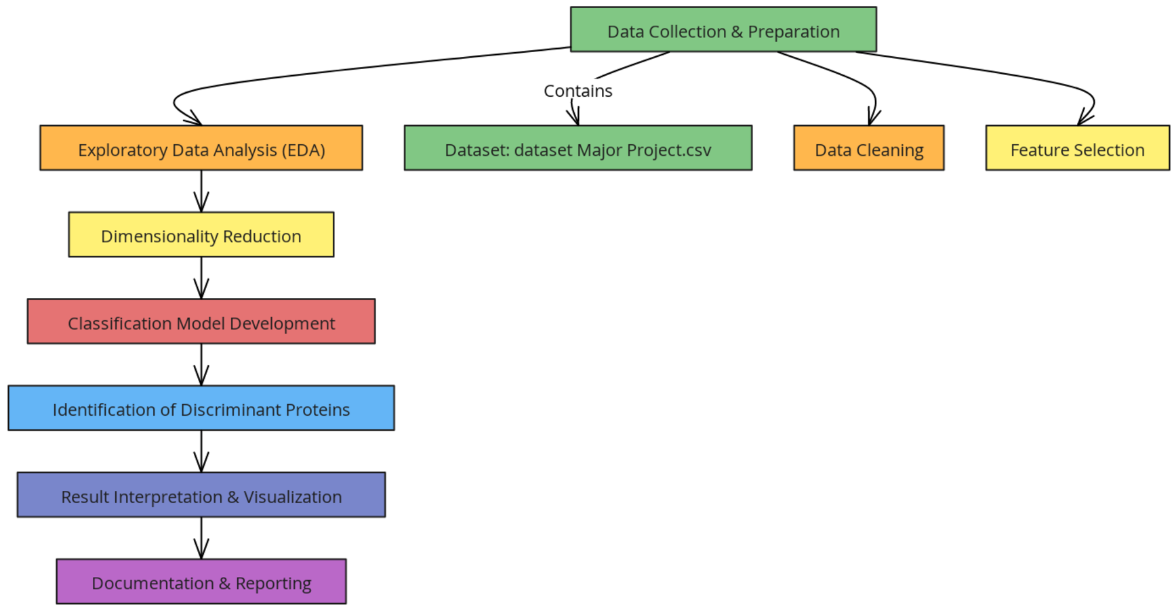

**Annexure B**

**Entity-Relationship Diagram (ERD)**

**(Mandatory)**

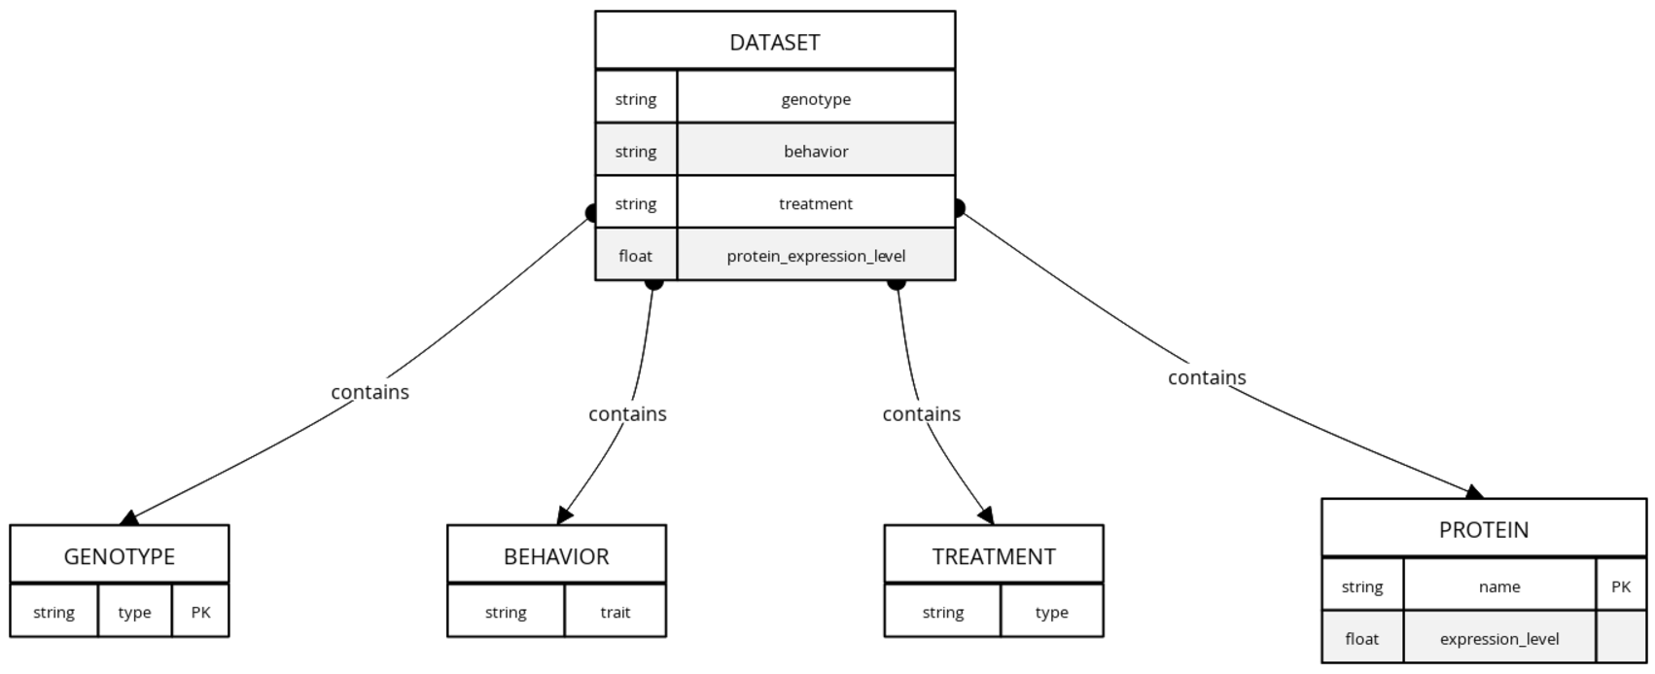

**Annexure C**

**Use-Case Diagram (UCD)**

**(Optional)**

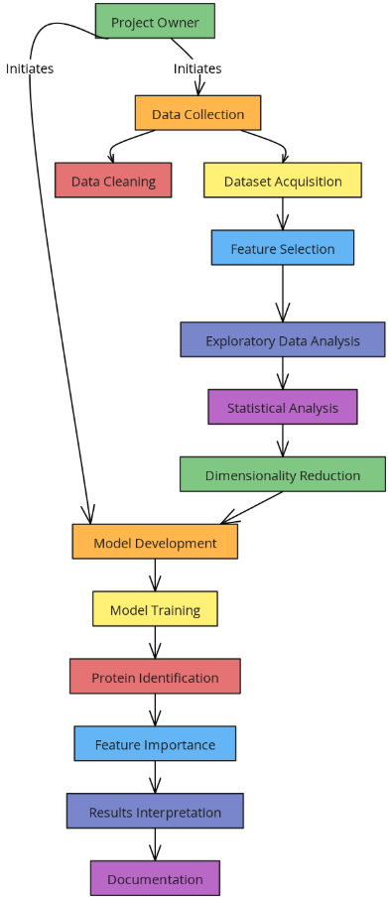

**Annexure D**

**Data Dictionary (DD)**

**(Mandatory)**

### 1. ****Mice Table (MICE)****

| **Fields** | **Data Type** | **Description** |
| --- | --- | --- |
| MICE-ID | Number | Unique ID assigned to each mouse |
| MICE-Genotype | Text | Genotype of the mouse (e.g., Wild-type, Mutant) |
| MICE-Behavior | Text | Behavioral traits (e.g., Active, Passive) |
| MICE-Treatment | Text | Treatment applied (e.g., Control, Experimental) |

### 2. ****Protein Expression Table (PROTEIN)****

| **Fields** | **Data Type** | **Description** |
| --- | --- | --- |
| PROTEIN-ID | Number | Unique ID for each protein |
| PROTEIN-Name | Text | Name of the protein (e.g., Protein A, Protein B) |
| PROTEIN-Level | Number | Quantitative measure of protein expression level |
| PROTEIN-MICE-ID | Number | Mice ID associated with the protein expression |

### 3. ****Dataset Table (DATASET)****

| **Fields** | **Data Type** | **Description** |
| --- | --- | --- |
| DATASET-ID | Number | Unique identifier for each dataset entry |
| DATASET-MICE-ID | Number | Mice ID linked to a specific dataset entry |
| DATASET-PROTEIN-ID | Number | Protein ID linked to the dataset |
| DATASET-Genotype | Text | Genotype class (e.g., Wild-type, Mutant) |
| DATASET-Behavior | Text | Behavioral classification |
| DATASET-Treatment | Text | Treatment classification |
| DATASET-Protein-Level | Number | Protein expression level |

### 4. ****Classification Model Table (MODEL)****

| **Fields** | **Data Type** | **Description** |
| --- | --- | --- |
| MODEL-ID | Number | Unique model identifier |
| MODEL-Type | Text | Type of classification model (e.g., SVM, Random Forest) |
| MODEL-Accuracy | Decimal | Accuracy of the model |
| MODEL-Precision | Decimal | Precision of the model |
| MODEL-Recall | Decimal | Recall of the model |

### 5. ****Discriminant Proteins Table (DISCRIMINANT)****

| **Fields** | **Data Type** | **Description** |
| --- | --- | --- |
| DISCRIMINANT-ID | Number | Unique ID for discriminant protein |
| DISCRIMINANT-Protein-Name | Text | Name of the protein identified as a discriminant |
| DISCRIMINANT-Protein-Level | Number | Expression level that differentiates the classes |
| DISCRIMINANT-Model-ID | Number | Associated model ID that identified the protein |

### 6. ****Feature Importance Table (FEATURE)****

| **Fields** | **Data Type** | **Description** |
| --- | --- | --- |
| FEATURE-ID | Number | Unique ID for the feature |
| FEATURE-Protein-Name | Text | Protein name identified as an important feature |
| FEATURE-Importance-Score | Decimal | The score indicating the importance of the feature |

### 7. ****Data Cleaning Table (CLEANING)****

| **Fields** | **Data Type** | **Description** |
| --- | --- | --- |
| CLEANING-ID | Number | Unique ID for the cleaning process |
| CLEANING-Type | Text | Type of cleaning applied (e.g., Imputation, Standardization) |
| CLEANING-Method | Text | Method used for data cleaning |
| CLEANING-Notes | Text | Notes related to the cleaning process |

**Annexure E**

**Screen Shots**

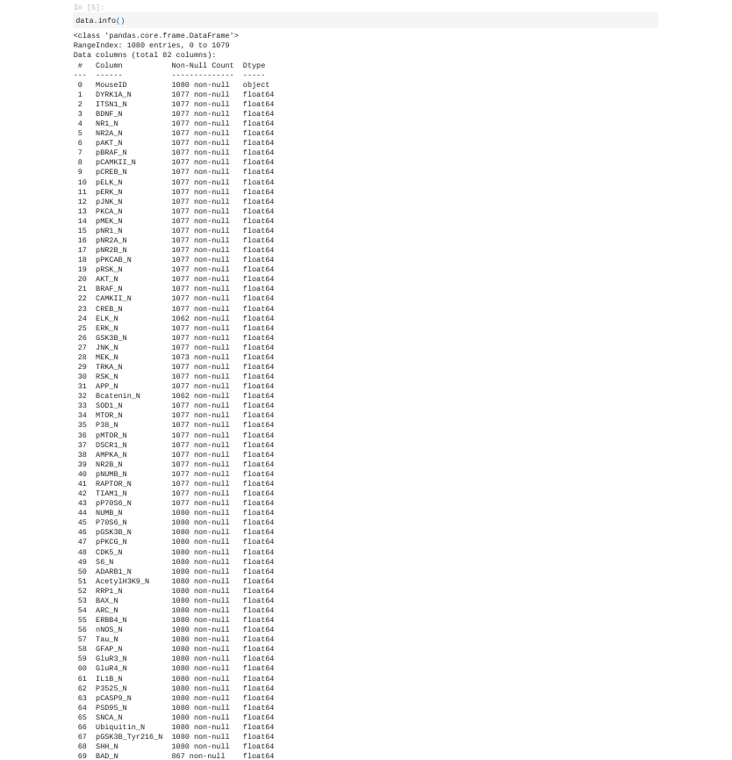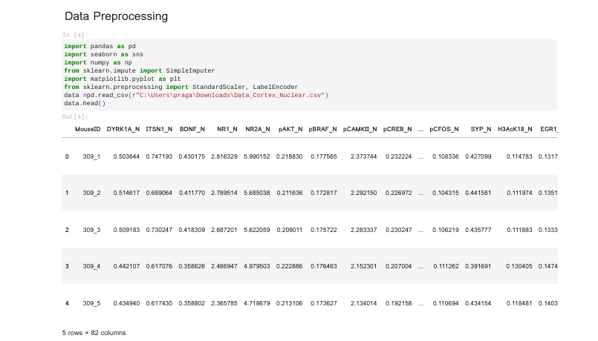

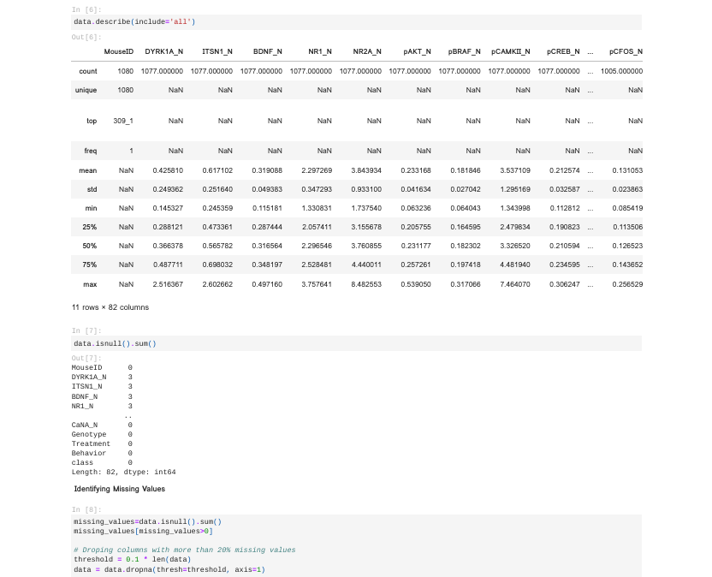

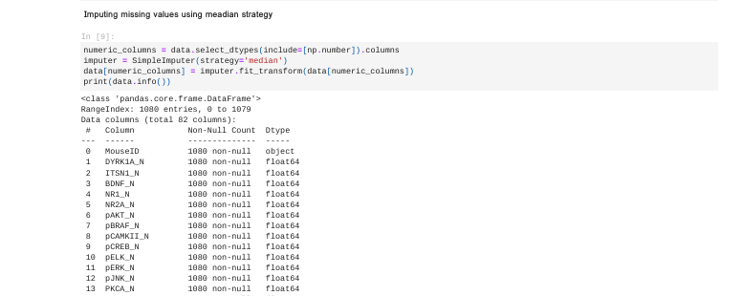

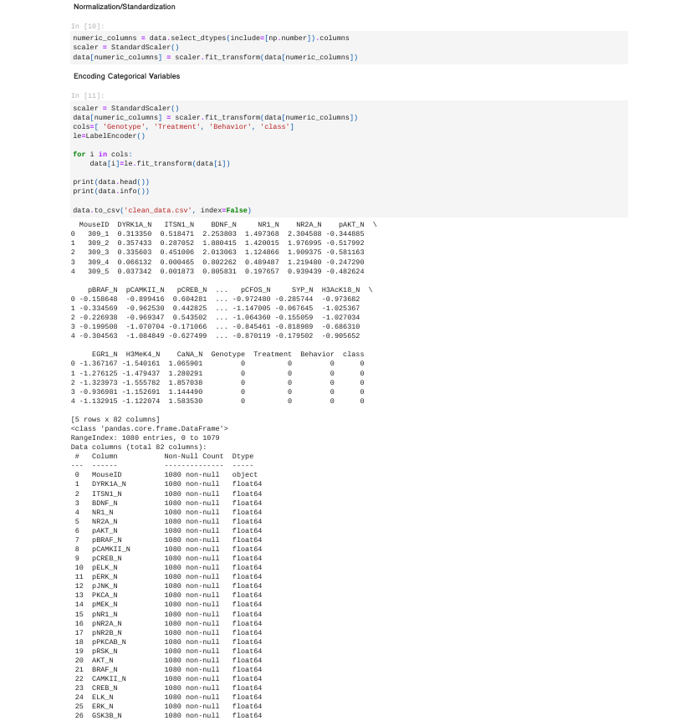

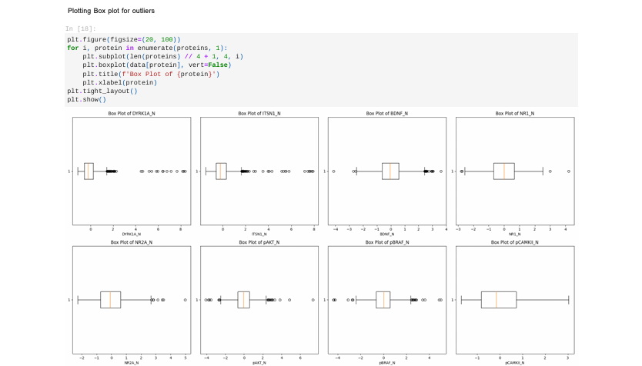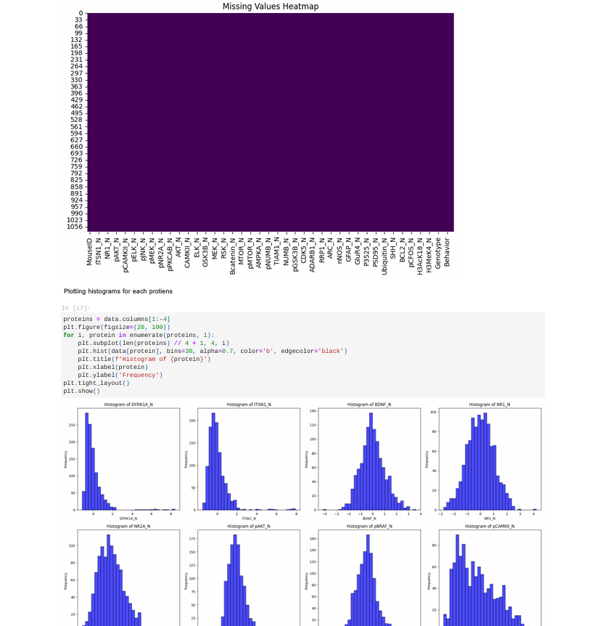

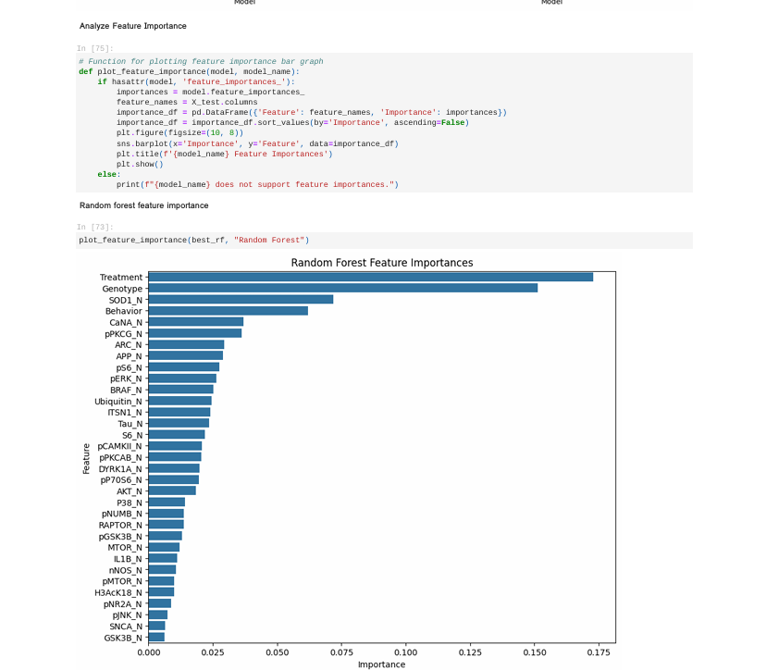

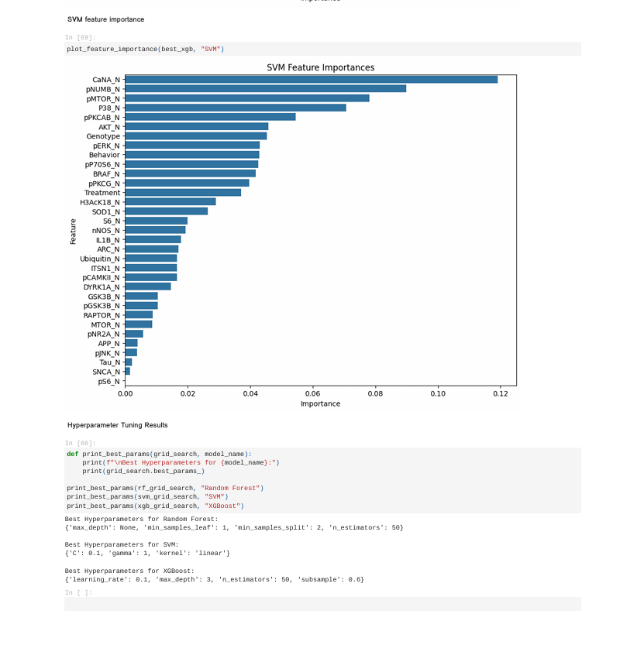

**THANK YOU!!**